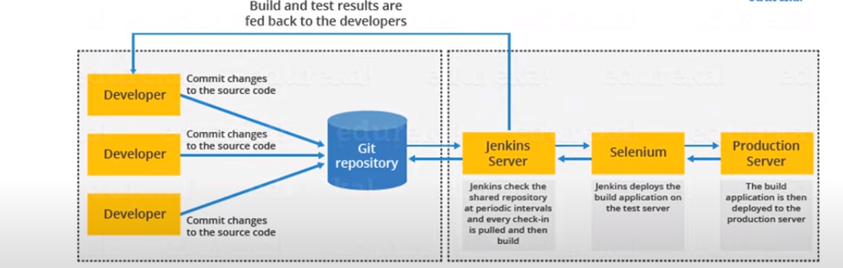

[The master-slave architecture in Jenkins is a way to distribute workloads across multiple nodes, improving efficiency and scalability](https://www.bing.com/ck/a?!&&p=98135757237f956bJmltdHM9MTcxMzQ4NDgwMCZpZ3VpZD0yNDJmOGI3Ny1jYTMzLTZhMjktM2YyYy05ZjQ4Y2I4MTZiMjMmaW5zaWQ9NTg2MA&ptn=3&ver=2&hsh=3&fclid=242f8b77-ca33-6a29-3f2c-9f48cb816b23&psq=master+slave+architecture+in+jenkins&u=a1aHR0cHM6Ly9oYXJzaDA1Lm1lZGl1bS5jb20vc2ltcGxpZnlpbmctamVua2lucy1tYXN0ZXItc2xhdmUtYXJjaGl0ZWN0dXJlLWEtY29tcHJlaGVuc2l2ZS1ndWlkZS04NGY3ZGU2NjIzNDY&ntb=1)[**1**](https://www.bing.com/ck/a?!&&p=3666a7eb31bc2c63JmltdHM9MTcxMzQ4NDgwMCZpZ3VpZD0yNDJmOGI3Ny1jYTMzLTZhMjktM2YyYy05ZjQ4Y2I4MTZiMjMmaW5zaWQ9NTg2MQ&ptn=3&ver=2&hsh=3&fclid=242f8b77-ca33-6a29-3f2c-9f48cb816b23&psq=master+slave+architecture+in+jenkins&u=a1aHR0cHM6Ly9oYXJzaDA1Lm1lZGl1bS5jb20vc2ltcGxpZnlpbmctamVua2lucy1tYXN0ZXItc2xhdmUtYXJjaGl0ZWN0dXJlLWEtY29tcHJlaGVuc2l2ZS1ndWlkZS04NGY3ZGU2NjIzNDY&ntb=1)[**2**](https://www.bing.com/ck/a?!&&p=df88bc5faf6b4cefJmltdHM9MTcxMzQ4NDgwMCZpZ3VpZD0yNDJmOGI3Ny1jYTMzLTZhMjktM2YyYy05ZjQ4Y2I4MTZiMjMmaW5zaWQ9NTg2Mg&ptn=3&ver=2&hsh=3&fclid=242f8b77-ca33-6a29-3f2c-9f48cb816b23&psq=master+slave+architecture+in+jenkins&u=a1aHR0cHM6Ly9zYXlhbnRhbnNhbWFudGEwOTgubWVkaXVtLmNvbS9qZW5raW5zLW1hc3Rlci1zbGF2ZS1hcmNoaXRlY3R1cmUtd2l0aC1kb2NrZXItNWQ3YTM5YWQ3Yzkw&ntb=1)[**3**](https://www.bing.com/ck/a?!&&p=a9ead7a4baaf5a98JmltdHM9MTcxMzQ4NDgwMCZpZ3VpZD0yNDJmOGI3Ny1jYTMzLTZhMjktM2YyYy05ZjQ4Y2I4MTZiMjMmaW5zaWQ9NTg2Mw&ptn=3&ver=2&hsh=3&fclid=242f8b77-ca33-6a29-3f2c-9f48cb816b23&psq=master+slave+architecture+in+jenkins&u=a1aHR0cHM6Ly9jbG91ZHplbmlhLmNvbS9ibG9nL3VuZGVyc3RhbmRpbmctbWFzdGVyLXNsYXZlLWFyY2hpdGVjdHVyZS1pbi1qZW5raW5zLw&ntb=1)[**4**](https://www.bing.com/ck/a?!&&p=4f9cba2d741dea81JmltdHM9MTcxMzQ4NDgwMCZpZ3VpZD0yNDJmOGI3Ny1jYTMzLTZhMjktM2YyYy05ZjQ4Y2I4MTZiMjMmaW5zaWQ9NTg2NA&ptn=3&ver=2&hsh=3&fclid=242f8b77-ca33-6a29-3f2c-9f48cb816b23&psq=master+slave+architecture+in+jenkins&u=a1aHR0cHM6Ly9kem9uZS5jb20vYXJ0aWNsZXMvamVua2lucy0wMy1jb25maWd1cmUtbWFzdGVyLWFuZC1zbGF2ZQ&ntb=1). [In this setup, the Jenkins master node serves as the central controller responsible for managing job execution and distributing tasks to one or more slave nodes](https://www.bing.com/ck/a?!&&p=d505c7d0e209f510JmltdHM9MTcxMzQ4NDgwMCZpZ3VpZD0yNDJmOGI3Ny1jYTMzLTZhMjktM2YyYy05ZjQ4Y2I4MTZiMjMmaW5zaWQ9NTg2NQ&ptn=3&ver=2&hsh=3&fclid=242f8b77-ca33-6a29-3f2c-9f48cb816b23&psq=master+slave+architecture+in+jenkins&u=a1aHR0cHM6Ly9oYXJzaDA1Lm1lZGl1bS5jb20vc2ltcGxpZnlpbmctamVua2lucy1tYXN0ZXItc2xhdmUtYXJjaGl0ZWN0dXJlLWEtY29tcHJlaGVuc2l2ZS1ndWlkZS04NGY3ZGU2NjIzNDY&ntb=1)[**1**](https://www.bing.com/ck/a?!&&p=a063ded7b8d7f8efJmltdHM9MTcxMzQ4NDgwMCZpZ3VpZD0yNDJmOGI3Ny1jYTMzLTZhMjktM2YyYy05ZjQ4Y2I4MTZiMjMmaW5zaWQ9NTg2Ng&ptn=3&ver=2&hsh=3&fclid=242f8b77-ca33-6a29-3f2c-9f48cb816b23&psq=master+slave+architecture+in+jenkins&u=a1aHR0cHM6Ly9oYXJzaDA1Lm1lZGl1bS5jb20vc2ltcGxpZnlpbmctamVua2lucy1tYXN0ZXItc2xhdmUtYXJjaGl0ZWN0dXJlLWEtY29tcHJlaGVuc2l2ZS1ndWlkZS04NGY3ZGU2NjIzNDY&ntb=1)[**2**](https://www.bing.com/ck/a?!&&p=595b03cece7d300fJmltdHM9MTcxMzQ4NDgwMCZpZ3VpZD0yNDJmOGI3Ny1jYTMzLTZhMjktM2YyYy05ZjQ4Y2I4MTZiMjMmaW5zaWQ9NTg2Nw&ptn=3&ver=2&hsh=3&fclid=242f8b77-ca33-6a29-3f2c-9f48cb816b23&psq=master+slave+architecture+in+jenkins&u=a1aHR0cHM6Ly9zYXlhbnRhbnNhbWFudGEwOTgubWVkaXVtLmNvbS9qZW5raW5zLW1hc3Rlci1zbGF2ZS1hcmNoaXRlY3R1cmUtd2l0aC1kb2NrZXItNWQ3YTM5YWQ3Yzkw&ntb=1)[**4**](https://www.bing.com/ck/a?!&&p=0b641e40b33a81e7JmltdHM9MTcxMzQ4NDgwMCZpZ3VpZD0yNDJmOGI3Ny1jYTMzLTZhMjktM2YyYy05ZjQ4Y2I4MTZiMjMmaW5zaWQ9NTg2OA&ptn=3&ver=2&hsh=3&fclid=242f8b77-ca33-6a29-3f2c-9f48cb816b23&psq=master+slave+architecture+in+jenkins&u=a1aHR0cHM6Ly9kem9uZS5jb20vYXJ0aWNsZXMvamVua2lucy0wMy1jb25maWd1cmUtbWFzdGVyLWFuZC1zbGF2ZQ&ntb=1). [The master node schedules jobs and assigns slaves, and sends builds to slaves to execute the jobs](https://www.bing.com/ck/a?!&&p=bc61a175711a9751JmltdHM9MTcxMzQ4NDgwMCZpZ3VpZD0yNDJmOGI3Ny1jYTMzLTZhMjktM2YyYy05ZjQ4Y2I4MTZiMjMmaW5zaWQ9NTg2OQ&ptn=3&ver=2&hsh=3&fclid=242f8b77-ca33-6a29-3f2c-9f48cb816b23&psq=master+slave+architecture+in+jenkins&u=a1aHR0cHM6Ly9kem9uZS5jb20vYXJ0aWNsZXMvamVua2lucy0wMy1jb25maWd1cmUtbWFzdGVyLWFuZC1zbGF2ZQ&ntb=1)[**4**](https://www.bing.com/ck/a?!&&p=67a497f15493eed6JmltdHM9MTcxMzQ4NDgwMCZpZ3VpZD0yNDJmOGI3Ny1jYTMzLTZhMjktM2YyYy05ZjQ4Y2I4MTZiMjMmaW5zaWQ9NTg3MA&ptn=3&ver=2&hsh=3&fclid=242f8b77-ca33-6a29-3f2c-9f48cb816b23&psq=master+slave+architecture+in+jenkins&u=a1aHR0cHM6Ly9kem9uZS5jb20vYXJ0aWNsZXMvamVua2lucy0wMy1jb25maWd1cmUtbWFzdGVyLWFuZC1zbGF2ZQ&ntb=1). [The slave nodes handle the actual work](https://www.bing.com/ck/a?!&&p=dd03b214455d53ccJmltdHM9MTcxMzQ4NDgwMCZpZ3VpZD0yNDJmOGI3Ny1jYTMzLTZhMjktM2YyYy05ZjQ4Y2I4MTZiMjMmaW5zaWQ9NTg3MQ&ptn=3&ver=2&hsh=3&fclid=242f8b77-ca33-6a29-3f2c-9f48cb816b23&psq=master+slave+architecture+in+jenkins&u=a1aHR0cHM6Ly9zYXlhbnRhbnNhbWFudGEwOTgubWVkaXVtLmNvbS9qZW5raW5zLW1hc3Rlci1zbGF2ZS1hcmNoaXRlY3R1cmUtd2l0aC1kb2NrZXItNWQ3YTM5YWQ3Yzkw&ntb=1)[**2**](https://www.bing.com/ck/a?!&&p=b12f67994b3abf0cJmltdHM9MTcxMzQ4NDgwMCZpZ3VpZD0yNDJmOGI3Ny1jYTMzLTZhMjktM2YyYy05ZjQ4Y2I4MTZiMjMmaW5zaWQ9NTg3Mg&ptn=3&ver=2&hsh=3&fclid=242f8b77-ca33-6a29-3f2c-9f48cb816b23&psq=master+slave+architecture+in+jenkins&u=a1aHR0cHM6Ly9zYXlhbnRhbnNhbWFudGEwOTgubWVkaXVtLmNvbS9qZW5raW5zLW1hc3Rlci1zbGF2ZS1hcmNoaXRlY3R1cmUtd2l0aC1kb2NrZXItNWQ3YTM5YWQ3Yzkw&ntb=1).

single jenkins serevr might be enoght to meet certian requirements for ex

servral diff environ to test build this might be not possible with single server.

if larger and heavier project gets a freqent build then having single server can not handle the load so to handle this distrubuted Jenkins enviroment cam into picture.

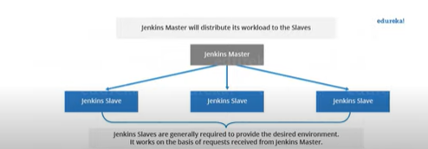

Mastre and slave communicate via a tcpip protocol

Master :

Sche build jobs, dispatching builds to the salve for exe

Monitoring the salve node possibly taking them online and off line

Recoring and presenting the build result . it may also directly runs the Job.

Salve is a java executable that runs on a remote m/c

Hears the request from master , It runs of variety of OS.

Executing the build job dispatched by the master.

